**Experiment Name:** Installing the Java Environment with NetBeans.

**Objective:** The objective of this lab is to install and configure the Java environment using NetBeans.

**Introduction:** NetBeans is a popular Integrated Development Environment (IDE) for developing Java applications. It provides a user-friendly interface for writing, compiling, and running Java programs. In order to use NetBeans for Java development, you need to have the Java Development Kit (JDK) installed on your computer. The JDK includes the Java Runtime Environment (JRE) and the Java Virtual Machine (JVM), which are required to run Java programs.  
**JDK:**The JDK is a software development environment used for developing Java applications. It includes tools such as a compiler, debugger, and documentation generator.   
**JRE:**The JRE is a software package that provides the libraries and other components necessary to run Java programs.   
**JVM:**The JVM is a virtual machine that executes Java bytecode, which is the intermediate representation of Java programs that is generated by the compiler.

**Methodology:**

Select the appropriate version for operating system and download the JDK from the [Oracle website]. Also download NetBeans from the [NetBeans website]. Install by following the installation instructions to install NetBeans on computer. Like below steps:

|  |
| --- |
|  |
|  |





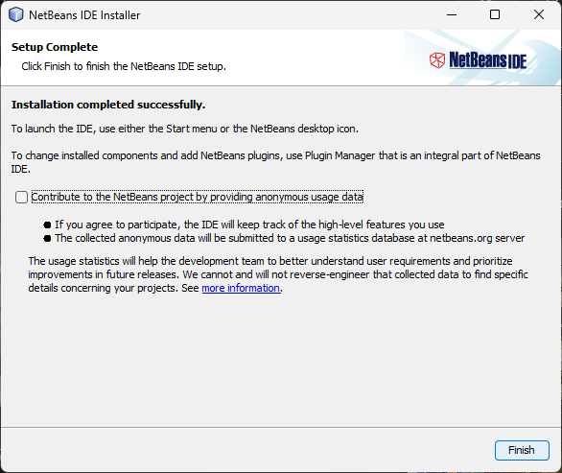

**Results:** The JDK and NetBeans 8.2 were successfully installed and configured on a Windows computer.

**Discussion:** Installing and configuring the Java environment with NetBeans is a straightforward process. NetBeans provides a user-friendly interface for developing Java applications, making it a popular choice among developers.

**Conclusion:** This lab demonstrated how to install and configure the Java environment using NetBeans 8.2. The process was successful and a simple Java program was written, compiled, and run using NetBeans.